

**Diploma in ICT & Computing**

**Unit 03 - End User Applications**

**Practical Examination Paper**

***Time :2 Hours***

***Instructions to Invigilators,***

***No reference material of any kind be taken in to the examination hall by the students*.**

**Task 1**

**Create the following using MS Word 2013 (25 Marks)**

ttgtttt 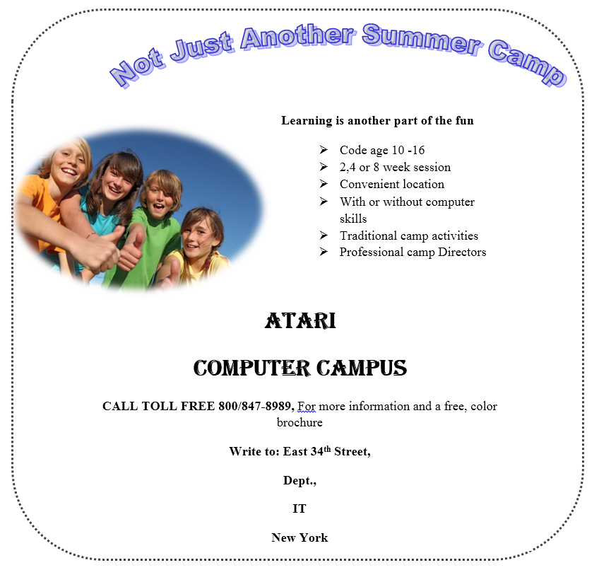

**Task 2 (25 Marks)**

**You are supposed to create a spreadsheet using MS Excel 2013, by following the instructions given below.**

**Anne College**

**Mark Sheet for A/L Biology-Class A**

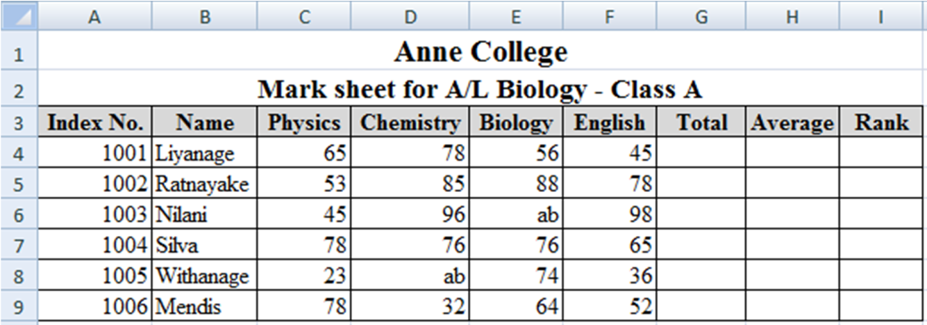

1. Insert a title "Anne College" and a sub title "Mark sheet for A/L Biology - Class “A”, by centering it with the table, making the text bold, and changing the font size 16 for main title and 14 for subtitle.
2. The relevant formula to calculate the total marks & average mark*.*
3. Calculate the rank using logical if function
4. If(average>75,rank is “A”.
5. If(average>50, rank is “B”.
6. Otherwise rank is “F”.
7. Use conditional formatting to change the color of the cells of which the average mark is more than 60, in to *green*.
8. Draw the following chart using the following table.

**Task 3 (25 Marks)**

1. Create a database as **“Books details**”.
2. Create a table as “**Books”.**

|  |  |  |  |
| --- | --- | --- | --- |
| **Field Name** | **Type** | **Field size** | **Constraints** |
| ID | Number |  | Primary Key |
| Title | Text | 50 characters |  |
| Description | Text | 30 characters |  |
| Category | Number |  |  |
| No of copies | Number |  |  |

1. Add following records to the “**Books**” table

|  |  |  |  |  |
| --- | --- | --- | --- | --- |
| **ID** | **Title** | **Description** | **Category** | **No of copies** |
| 1 | Word | Hard cover | 2 | 2 |
| 2 | Computers | Hard .cover | 4 | 2 |
| 3 | Access | Paperback | 2 | 2 |
| 4 | Art | Hard cover | 1 | 1 |
| 5 | Science | Paperback | 3 | 1 |

1. Create another table called “**Book Copies**” with the following fields.

|  |  |
| --- | --- |
| **Field Name** | **Type** |
| ID | Number |
| Book _ID | Number |
| ISBN | Number |
| Version | Number |

1. Insert following records to the “**Book Copies**” table.

|  |  |  |  |
| --- | --- | --- | --- |
| **ID** | **Book ID** | **ISBN** | **Version** |
| 1 | 1 | 1234 | 1 |
| 2 | 1 | 1235 | 2 |
| 3 | 2 | 1236 | 1 |
| 4 | 2 | 1237 | 3 |
| 5 | 3 | 1238 | 2 |

1. Create a relationship between the 2 tables.
2. Create the forms and reports for the 2 tables (using wizard).
3. Write a query called “**Query Book category**” to display all books which belongs to Category “2”.

**Task 4 (25 Marks)**

1. Create the following using Ms PowerPoint 2013(Additional marks will be awarded for proper usage of animation ,silde transitions and action buttons.)

